

ANALYSIS DOCUMENT

FOR INFORMATION

DEVELOPMENT

SYSTEM -

DATA MODEL

Project Phase 3

Take One movie Theatre Ticketing System

 | GROUP 19
Johané le Roux | 31614744
Christopher Slaghuis | 31713858
Jean Marx | 32313845
Reinhardt Nel | 27327884
James Uys | 28461789

Data Model Phase 3 Group 19

Contents

Data Model 2

Marking Guide 3

1 | P a g e
Data Model Phase 3 Group 19

Data Model
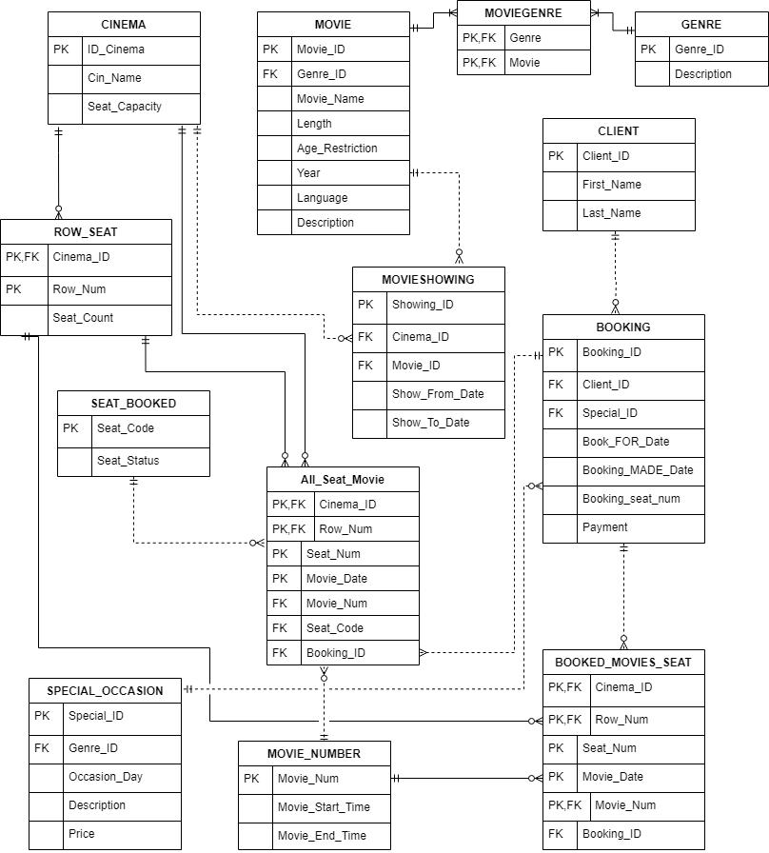

2 | P a g e
Data Model Phase 3 Group 19

Marking Guide

CMPG213 Marking Guide for Analysis Document 2020

Group Number: |  | 19
Members: | Johané le Roux |  | Student No: 31614744
 | Christopher Slaghuis |  | 31713858
 | Jean Marx |  | 32313845
 | Reinhardt Nel |  | 27327884
 | James Uys |  | 28461789

System to implement: |  |  | Take One Movie Theater
 |  |  | Item | Maximum | Group’s
 |  |  |  | Mark | Mark
 | Project scope (Updated from previous documents and specific) |  |  | 5
 | Use-case diagram (must include association relationships and |  |  | 15
 | at least one <<depends on>> relationship)
 | • | Use-cases
 | • | Actors
 | • | Associations
 | • | <<depends on>> relationship
 | • Frame and system name
 | Fully attributed data model (example Fig 8-16 P 297) |  |  | 20
 | • | Entities
 | • | Attributes
 | • | Primary keys
 | • | Foreign keys
 | • Relationships (weak/strong, verb, cardinality)
 | • | 3NF
 | Process models (Only primitive diagrams, i.e. lowest level of |  |  | 30
 | detail)
 | • | Agents
 | • | Processes
 | • | Data Stores
 | • | Data flows
 | Scope, Use-case diagram, data models and process models |  |  | 10
 | are integrated, e.g.
 | • dataflows contain attributes of entities,
 | • all actors appear as agents in process models,
 | • all use cases appear as processes in process models
 | • all entities appear as data stores in process models
 | • all use-cases refer to entities in data model
 | TOTAL |  |  | 80

3 | P a g e
Data Model Phase 3 Group 19

Comments:

_________________________________________________________

_________________________________________________________

_________________________________________________________

_________________________________________________________

4 | P a g e

